**AVAILBLE HOMES IN WINDMILL RIDGE**

830-895-3003 **SPEARS HOMES LISTINGS** www.spearshomes.com

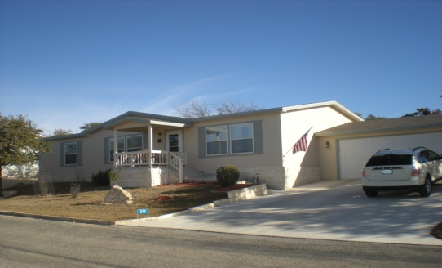

**506 N. Buckboard (3/2)**  **$135,000**

Large rooms throughout! The master, living and guest are all spacious. Storage galore with three walk in closets and an oversized two car garage. Spotless! Patriot Homes quality!

**314 Cattail Creek** **$129,500**

Wonderful light and bright Karsten with 2 car garage. This 3/2 bath has a huge master bedroom and three walk in closets. Beautiful wood flooring. Tons of energy saving features! Must see to appreciate!

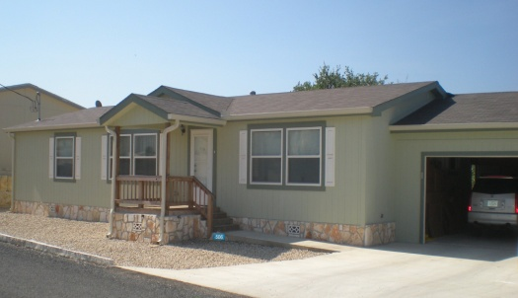

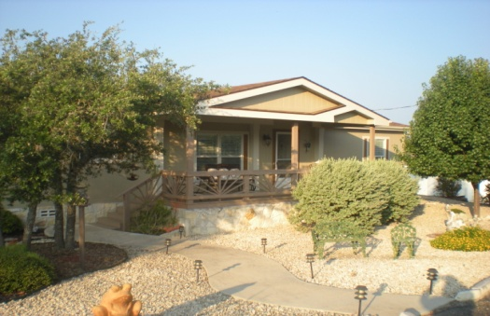

**125 Purple Sage (REDUCED)** **$109,900**

Neat as a pin! Great floor plan with entertainers’ in mind. Breakfast nook, sunroom, three bedrooms, fireplace, Tons of cabinets in the garage. This one is a must see!

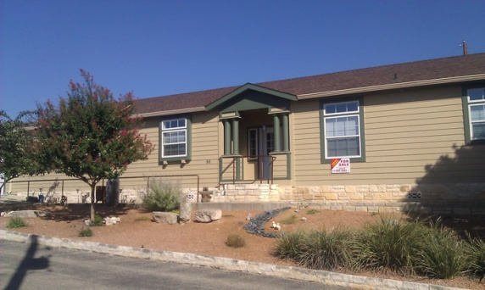

**86 Purple Sage $119,000**

Over 2,000 sq. ft. beautiful top of the line Patriot home with 9 ½ foot ceilings, art niches, incredible construction, large back deck, two car garage and impeccable quality. 3/2

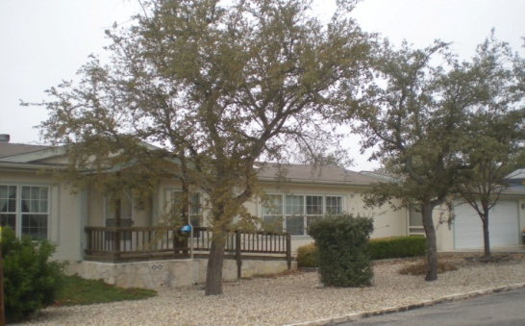

**217 Painted Rock $84,500**

WOW! Lowest price in Windmill Ridge 3/2 Schult Large living, dining and master bedroom . Light and airy . Front kitchen with lots of storage. Features a screened room and a ramp for easy access from the garage. Great buy !

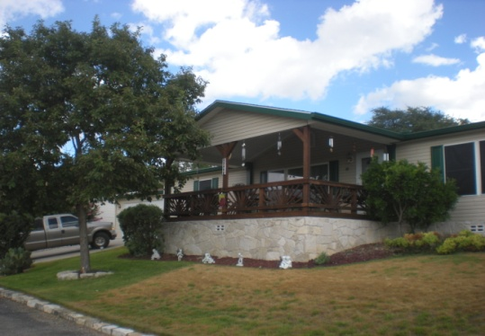

**346 Coyote Ridge $105,000**

Wonderful view from large covered deck . This 3/2 Saturn home has 2x6 walls, upgrade insulation, thermopane windows, a new high efficiency Carrier a/c , new roof, a great open and spacious split floorplan and a great workshop!

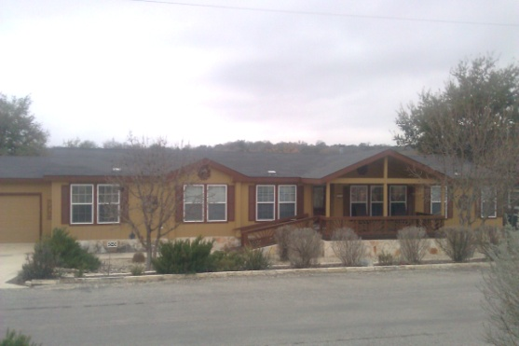

**301 Cattail Creek** (**NEW LISTING)** **$134,500**

Over 2,200 sq feet! 4/3 Fantastic home on the greenbelt with 12x40 deck!! Wonderful split plan lay out with large master bedroom. This home features office, living room, den, guest bedroom and convenient Jack and Jill bath. This one is a must see!

**123 Cattail Creek (NEW LISTING) $82,500**

What a deal! 3/2 with beautiful greenbelt location! This Schult home has been updated with lovely designer colors. It features large master and guest bedrooms. There is a dining area as well as a comfy breakfast nook! Come see! All that’s missing is you!

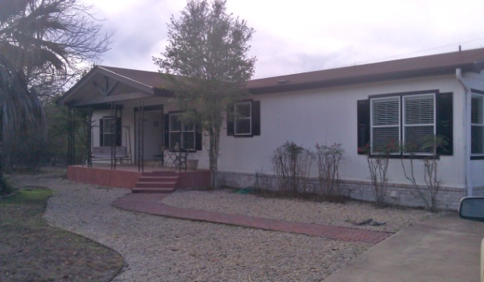

Homes for sale in Riverfront Village

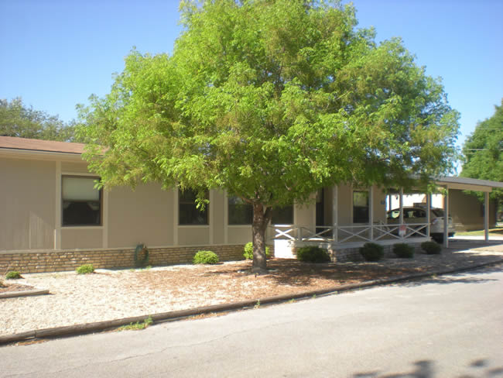

**115 Birch $55,900**

Light and bright! New paint, new carpet, eat at breakfast bar large dining and HUGE living room this home is big on square footage and low on price! Large carport and storage room! Put this on your list to come see!

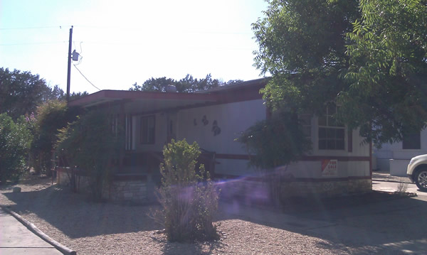

PENDING

**94 Pine Trail $24,900**

Looking for a great buy in a retirement community with river access? This cute 2/2 has a nice car port, storage building, and large covered front porch. Great summer retreat or Winter Texan’s haven.

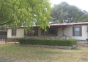

**116 Birch $69,900 REDUCED!**

Steps from the river the 3/2 has a great open concept design, large fireplace in the living room and new tile in the kitchen. This home has been lovingly cared for. It has a great front deck and nice screened porch in the back!

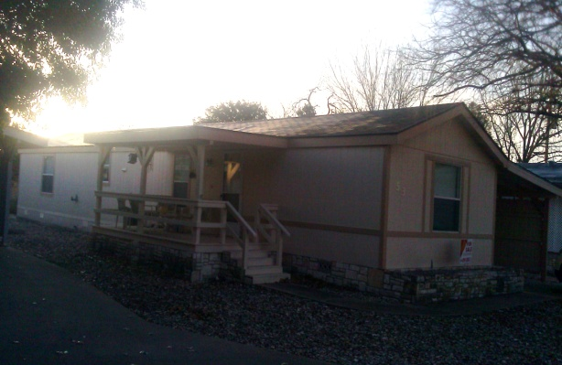

**53 Maple** (**NEW LISTING**) **$36,500**

Bright and open newer year model 2/2. Very comfortable floorplan with large master lots of storage and many recent upgrades. Move in ready with no yard maintenance . a great value on a nice home.

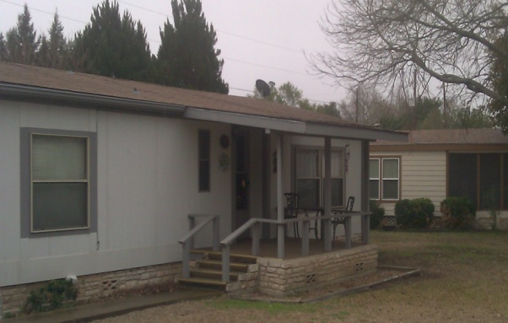

**31 Riverfront** (**NEW LISTING**) **$52,500**

2/2 This floor plan features a large living room and open concept dining and kitchen. The back yard is fenced perfect place for small dog. There is also a nice size covered drive and storage area. Needs a little TLC motivated seller easy to show.

Homes for sale in Live Oaks

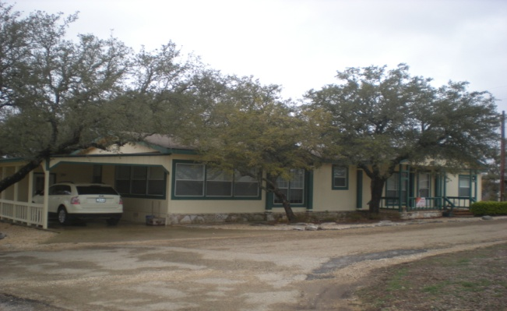

**100 Ridgetop Pass #91 $81,500**

1904 sq. ft. Great size value! This lovely three bedroom/ two bath home has two living areas, a formal dining area, a great kitchen a VERY large back deck and lots of beautiful TREES! This one won’t last long.